**4.n.1 SwapAnimation Design**

The animation of the sorting process depends on a component called SwapAnimation. It is used to animate an array of numbers as bars with different height, representing each number's value. It is designed to provide a smooth animation of swapping elements. Bars will not suddenly swap their position. Instead, this component can smoothly modify bars' colours, x-axis and y-axis values to visualise the comparing, swapping process intuitively. In figure 1, an array of numbers [3, 5, 7, 10, 8, 12] is visualised into bars with different heights and colours.

Figure 1. Bars with different colours and heights

SwapAnimation takes a property called trace, an array of bar states in a sequence of time frames. Each element in the trace array contains values and colours of bars and an explanation sentence displayed in the white explanation box in the middle. After each specific time interval, this component will visualise one of a series of bars in order to illustrate the process of sorting.

As for the states changing, to illustrate the process continuously and smoothly, the swapping process is displayed in a linear way. Both position and colour of a bar can be changed linearly, which means their changes would not be sudden. In figure 2, both position and colour property have transitions for change.

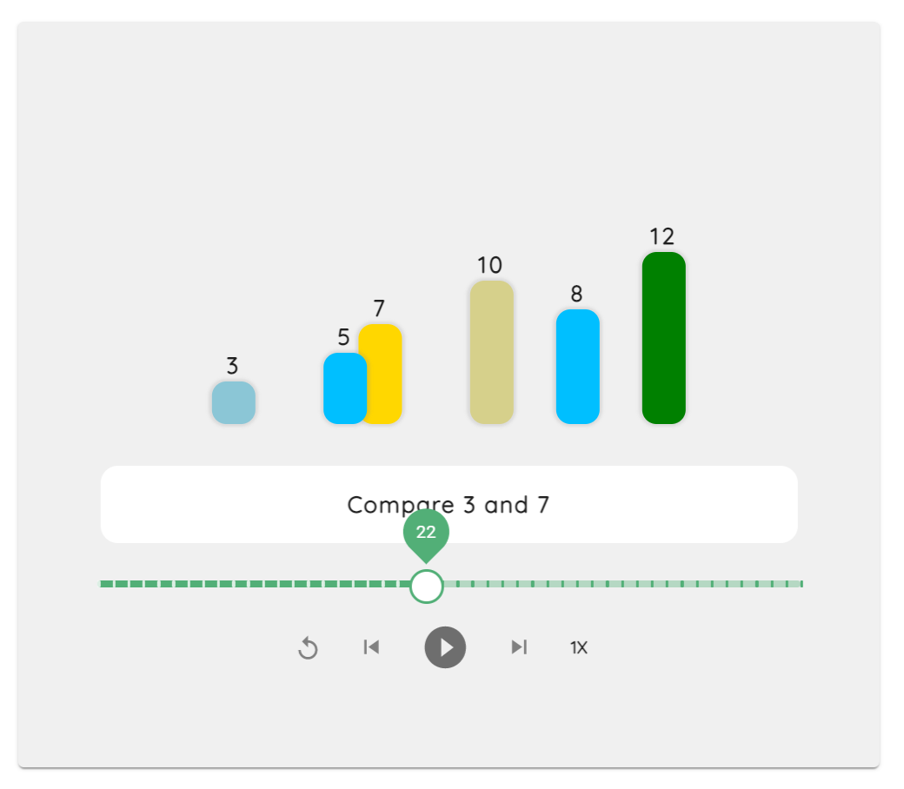

Figure 2. Bars are swapping and changing colours in the step 22

Since algorithms such as merge sort have both swapping and splitting operations, x and y-axis are utilised to visualise splitting an array into two parts. In figure 3, bars 1, 2, 6, 10 on the left are separated from the right part by changing their x and y-axis. The pivots under those bars indicate which bars are being processed at the current stage.

Figure 3. Bars are separated with pivots under them

SwapAnimation also provides functionality for users to control the animation. The horizontal green bar with a thumb on it is a progress bar for locating a specific time frame as users want. Five buttons below are reset, step backwards, play/pause and speed for controlling the animation.

InputBar is an alternative auxiliary component which allows user to type in numbers to create a self-defined array of bars for visualisation. This component has the functionality to restrict user input. An error message will be shown if users tried to visualise an array with a large number or size or characters other than integers. A shuffle button shuffles the bars with random size and numbers.

Figure 4. Input bar